DESSERT INNOVATION BASED ON LOCAL RESOURCES ON MOUSSE WITH MILLET FLOUR SUBSTITUTION

Aprianti Rosita¹, Wika Rinawati²
¹Universitas Negeri Yogyakarta; ²Faculty of Engineering
E-mail: aprianti.rosita2016@student.uny.ac.id

ABSTRAK
Tujuan dari penelitian ini adalah 1) untuk mengetahui tingkat kesukaan terhadap mousse substitusi tepung millet 2) mengetahui kandungan karbohidrat, lemak, protein, abu, dan kadar air pada produk mousse dari substitusi tepung millet sebanyak 25%. Penelitian ini merupakan penelitian eksperimental, dengan membandingkan mousse yang menggunakan substitusi tepung millet sebanyak 25% dan mousse produk acuan. Tahapan pelaksanaan penelitian terdiri dari pembuatan mousse dengan substitusi tepung millet sebanyak 25%. Setelah itu dilakukan uji hedonik untuk mengetahui tingkat kesukaan. Berdasarkan hasil uji hedonik panelis terbatas 30 panelis terhadap rasa, aroma, warna, dan tekstur dari mousse substitusi tepung millet diperoleh nilai rerata tertinggi pada kriteria warna dengan nilai rerata 3,67, untuk aroma 3,57, untuk rasa 3,77, dan 3,53 untuk teksture. Pada saat panelis terbuka dari 80 panelis, diperoleh hasil nilai rerata tertinggi pada kriteria warna yaitu 3,52 diikuti dengan kriteria tekstur dengan nilai rerata 3,49, kemudian kriteria rasa dengan nilai rerata 3,43 dan kriteria dengan nilai rerata terendah yaitu aroma dengan nilai rerata 3,32. Berdasarkan hasil penelitian tersebut, maka produk tersebut merupakan produk yang dapat diterima oleh panelis dari segi warna, aroma, rasa, dan tekstur. Hasil uji mousse dengan sunstitusi tepung millet sebanyak 30% yaitu kadar air 52,04 %; kadar abu 0,96 %; lemak 30,51 %; protein total 5,29%; serat kasar 0,44 %; dan karbohidrat 11,20 %.

Keywords: Millet, tepung millet, mousse, dessert, uji kesukaan.

ABSTRACT
The purpose of this research is to 1) knowing the level of preference for mousse with millet flour substitution 2) knowing the carbohydrate, fat, protein, ash, and water content in mousse products from the 25% substitution of millet flour. This research is an experimental study, by comparing mousse using 25% substitution of millet flour and reference mousse product. The stages of the implementation of the study consisted of making mousse with 25% millet flour substitution. After that, a hedonic test is performed to determine the level of preference. Based on the limited scale hedonic test results on 30 panelists on taste, aroma, color, and texture of mousse millet flour substitution the highest mean value was obtained on the color criteria with a mean value of 3.67, for aroma 3.57, for taste 3.77, and 3.53 for textures. Furthermore, at the exhibition of the final project carried out a large-scale hendonic test of 80 panelists, the highest average value of mousse was obtained by substitution of millet flour which was on the color criteria of 3.52 followed by texture criteria with a mean value of 3.49, then the taste criteria with value average of 3.43 and the criteria with the lowest mean value are flavour with a mean value of 3.32. Based on the results of these studies, the product is a product that can be accepted by panelists in terms of color, flavour, taste and texture. The test result of mousse with 25% millet flour substitution namely water content 52.04%; 0.96% ash content; 30.51% fat; total protein 5.29%; crude fiber 0.44%; and carbohydrates 11.20%.

Keywords: Millet, millet flour, mousse, dessert, hedonic scale test

INTRODUCTION

Millet is a type of small seed cereal that was once the staple food of East and Southeast Asian communities before they planted other cereal plants. Millet is a minor economic plant but has a nutritional value similar to other food crops such as rice, corn, wheat, and other grain crops because millet plants themselves belong to the type of grain crops. Most people dont know millet as a source of food, so far millet plants have only been used as bird feed. Even though these plants can be processed into food sources by the community to support food security and anticipate hunger problems (Marlin, 2009 dalam Prabowo,2010)
The advantage of processing Millet seeds into flour makes it easier and more practical to apply and has a longer shelf life. Flour is one of the recommended alternative forms of intermediate products, because it is more resistant to storage, easy to mix, enriched with nutrients (fortified), formed, and cooked faster according to the demands of a modern practical life (Damardjati, 2000 dan Permana, 2015 dalam Sulistyaningrum, 2017). The use of millet flour is expected to have the appropriate characteristics to be made as raw material for various processed products (Haross dan Rosell, 2003 dalam Sulistyaningrum, 2017).
Millet used in this study is white millet which is a pearl millet type with a starch content of 71,6% (Abate dan Gomez, 1984 dalam Marta, 2016). The selection of this type of millet is because pearl millet has the highest potential compared to other millet types based on its characteristics or properties to be exploited commercially. In addition, white millet is also easily found in the market because it is commonly used as bird feed so that the availability of raw materials can be guaranteed.
Mousse is a cold dessert which in French means white foam. In fact this food is a light and soft cream pudding. While mousse according to its history is from France which is made from chocolate such as chocolate mousse dessert. Usually this mousse is combined with chocolate or fruit juice (Maulana, 2018).
This research is expected to be able to contribute significantly in developing dessert innovation with the substitution of local flour, millet flour, so that it enriches dessert innovations from local ingredients in Indonesia that are functional food and widely accepted. The purpose of this study was to determine the level of preference for mousse and find out the carbohydrate, fat, protein, ash, and water content in the mousse product from the substitution of millet flour.

METHOD

The research was conducted at the Laboratorium Boga Jurusan Pendidikan Teknik Boga dan Busana, Faculty of Engineering, Yogyakarta State University in January-April 2019.
Analysis of nutrient content was carried out at the Laboratory of Agriculture Technology Faculty , Gajah Mada University in April 2019.
The material used in making mousse with substitution of 25% millet flour is liquid milk, whipped cream, espresso powder, granulated sugar, egg yolk, gelatin powder, and millet flour The material used must have good quality and is suitable for use with characteristic: 1) liquid milk does not clot, does not smell bad, and has a distinctive smell of milk, and there is no change in texture and color; 2) whipped cream does not clot, the color and taste doesn’t change, and is flavorful like whipped cream; 3) typical flavored millet flour, no rancid smell, no lice; 4) sugar does not clot, does not tingle, there is no change in color; 5) egg yolk does not have foul-smelling, flavorful eggs, not from cracked egg shells, clean and fresh shells; 6) espresso powder does not clot, not fleshy, doesn’t change in color and taste; 7) powder gelatin does not clot, does not runny, and doesn’t changes in color and taste.
The equipment used in making mousse with 25% millet flour substitutes is saucepan,small container, silicon mold, balloon whisk, pipping bag, digital scales, measuring cups, and freezers.
This research is an experimental study, by comparing mousse using 25% substitution of millet flour and reference product mousse. The stages of the implementation of the study consisted of making mousse with substitution of millet flour as much as 25%. Flowchart of the mousse making process with the substitution of millet flour is presented in Figure 1.
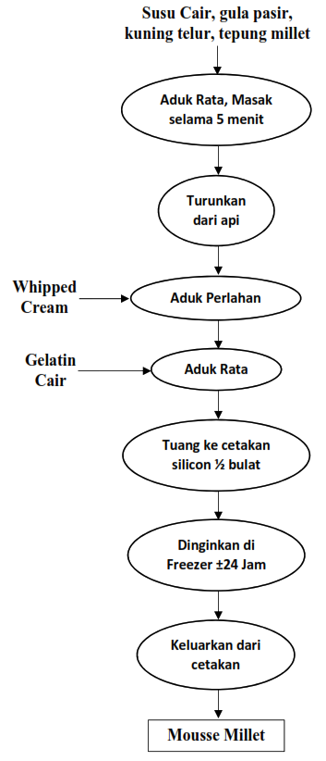
Figure 1. Flowchart of making mousse with 25% substitution of millet flour.

Test of the level of preference for the percentage of millet flour substitution is best done based on hedonic tests which include the criteria for texture, color, taste, and aroma of millet flour mousse using 4 hedonic scales. The scale used is 1 to be very disliked, 2 to be disliked, 3 to be liked, and 4 to be very liked. The number of panelists as many as 30 semi-trained panelists for limited research. . Panelists fill in forms to assess product substitution criteria and references to find out whether substitute products and reference products are significantly different.
Subsequently,substitution products were tested in the laboratory to determine the nutrient content including moisture content, fat content, total protein content, ash content, and crude fiber from substitute products. The last stage is the test of the panelists' preference for wide research with 80 panelists who are untrained panelists. Panelists gave a value to the substitution product with a scale of 1-4 for the criteria of color, smell, flavour and texture. The results of the preference level test forms are then averaged. Calculation of average values using Microsoft Excel. The average value of each experimental product was then compared in the form of bar charts for limited panelist research and wide panelist research. Analysis of nutrient content was carried out after limited panelist research.

RESULTS AND DISCUSSION

After 2 stages of testing, the test of preference level for limited panelist research to 30 semi-trained panelists and at the wide panelist research as many as 80 panelists were untrained, the results of the mousse with 25% millet flour substitution were obtained from the test. The results of the panelists level of preference for millet flour mousse products based on color, taste, smell, and texture can be seen in Figure 2.
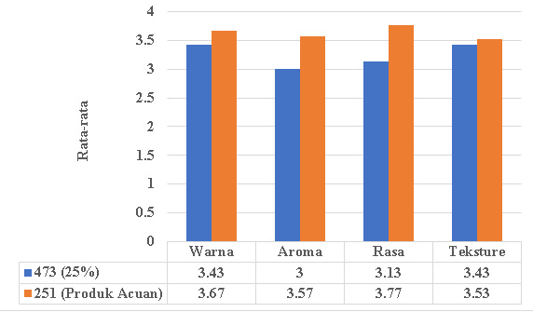
Figure 2. bar chart of average value of panelists preference for substitute products and millet flour mousse development products
Based on Figure 2, it is known that the test results of the hedonic scale test of 30 panelists in terms of taste, color, smell, and texture of millet flour mousse showed the highest mean value in the reference product with a mean value of 3.67 (preferred) for color, 3.57 (preferred ) for aroma, 3.77 (preferred) for flavor, and 3.53 (preferred) for texture. In figure 2, it is known that panelists prefer the color of the reference product with an average value of 3.67 compared to the substitution product with an average value of 3.43. This is because colored reference products are more concentrated and attractive compared to color substitution products that are more faded and gray. This color difference is influenced by the color of millet flour, which is grayish in color, which affects the final color of the product. However, the substitution product is still acceptable to panelists because it has an average value that is not too far behind.
Panelists prefer the smell of the reference product with an average value of 3.57 compared to a substitute product with an average value of 3. The aroma of millet flour has a characteristic that is less preferred by panelists, which smells unpleasant. The distinctive aroma of millet flour can still be smelled of the product, therefore panelists prefer the aroma of the reference product. From the average value, neutral Panelists are between likes and dislikes with the aroma of substitute products.
For the taste aspect, panelists preferred the taste of the reference product with an average value of 3.77 compared to the substitution product with an average value of 3.13. This is because substitution products still have a distinctive taste of millet flour, which is unpleasant to the panelists. In addition, substitute products also have a slightly bitter after taste. The average value of the substitute product and reference product is closely related. However, the taste of substitute products is still preferred and acceptable to panelists.
In the hedonic scale test of 80 panelists at the wide panelist research on millet flour mousse products based on color, smell, taste, and texture can be seen in Figure 3..

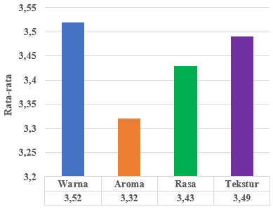
Figure 3. Bar chart of the Average value of millet flour mousse development products at the wide panelist research

Based on Figure 3, it is known that the results of the hedonic scale test for 80 panelists on mousse development products substituted for millet flour showed the highest mean value on color criteria, namely 3.52 followed by texture criteria with a mean value of 3.49, then taste criteria with a mean value of 3, 43 and the criteria with the lowest mean value are aroma with an average value of 3.32
Panelists like the color of the substitute product among other criteria, because the color of the product is considered a panelist is quite interesting and good when seen. Furthermore, for texture criteria, panelists like the texture of the development product because it is soft and does not feel coarse fiber.
On taste criteria, panelists still like the taste of product development but the average value is almost the lowest of all criteria. This is due to the fact that the panelists consider the taste of the development product to still feel a little unpleasant and typical of millet flour. However, panelists still like the taste of product development. For the smell criteria, it has the lowest value among all criteria. This is because the distinctive smell of millet flour still we can smell it. Panelists consider this smell to be less favored, but not too disturbing.

Proximate Test

Proximate test result of from mousse with 25% millet flour substitution namely 52.04% moisture content, 0.96% ash content, 30.51% fat content, 5.29% total protein content, 0.44% crude fiber, and 11,20% carbohydrate content.

CONCLUSION

The hedonic test results to determine the level of preference of panelists for taste, color, texture, and aroma of millet flour mousse showed the highest mean value on the color criteria and the lowest average value on the aroma criteria. Overall, panelists liked and were able to receive 25% mousse flour substitution products.
The test results of the nutrient content of mousse substituted with millet flour which had the highest nutrient content were 52.04% moisture content, followed by fat content 30.51%, carbohydrate content 11.20%, total protein 5.29%, and crude fiber 0.44 %.

REFERENCES

- Prabowo,B. “Kajian Sifat Fisookimia Tepung Millet Kuning dan Tepung Millet Merah”, 2010, Universitas Sebelas Maret
- Sulistyaningrum,A. “Karakteristik Tepung Jewawut (Foxtail Millet) Varietas Lokal Majene dengan Perlakuan Perendaman”, 2017, Balai Penelitian Tanaman Serealia
- Marta, H. “Sifat Fungsional dan Amilografi Pati Millet Putih (Pennisetum glaucum) Termodifikasi secara Heat Moisture Treatment dan Annealing”,2016, Universitas Padjajaran
- Maulana, A. “Pengolahan dan Penyajian Mousse Cake dengan Buah Nangka dan Sari Lemon, 2018, Politeknik Negeri Samarinda.

