RED VELVET CAKE SUBTITUTION BROWN RICE FLOUR INNOVATION OF FIBER DESSERT PRODUCTS

Sabilah Dwiyanti¹, Sugiyono²
¹Pendidikan Teknik Boga, Fakultas Teknik, Universitas Negeri Yogyakarta
E-mail: sabilah.dwiyanti2016@student.uny.ac.id

ABSTRACT

In Indonesia there are various types of cereals with various colors, varieties and shapes, which are potentially potential to add variety and nutrients in various patriotic products. Brown rice is a type of rice (Oryza sativa L.) with high anthocyanin content so that the red color of rice contains more components of nutrients and non-nutrients such as dietary fiber, phytic acid. vitamin E and vitamin B and γ-aminobutyric acid (GABA). One of the cake products is red velvet cake. The selection of red velvet cake products in the final project aims to: 1) Determine the standard red velvet cake recipe with the substitution of brown rice flour, 2) determine the community's acceptance of red velvet cake products with the substitution of brown rice flour. The type of research used in making this product is Reaserch and Development (R & D) with a 4D development model (Define, Design, Develop, Disseminate). The results obtained from the research of this product are the right recipe for Red Velvet Cake products. Red Rice Flour Substitution is a product with a percentage of 30% brown rice flour and 70% wheat flour and this product also has nutritional value information to show that the product is acceptable by the community .

Keywords: red velvet cake, brown rice and dietary fiber.

INTRODUCTION

In Indonesia there are various types of cereals with various colors, varieties and shapes, which are potentially potential to add variety and nutrients in various patriotic products. Many things have been done to further raise the types of cereals, such as brown rice, millet, “jali-jali” , corn and sorghum, but the use of these types of cereals has not been popular or not yet widely known.

Brown rice is a type of rice (Oryza sativa L.) with high anthocyanin content so that the rice has a red color. Anthocyanin not only plays a role in giving color, but also is an antioxidant that is good for health. This rice has a lower glycemic index (GI) while has a higher nutrient, fiber, vitamin and mineral content than white rice. According to Indriyani (2013), there are 7.5 grams of brown rice with 7.5 grams of protein, 0.9 grams of fat, 77.6 grams of carbohydrates, 0.3 grams of iron, and 0.00021 grams of vitamin B1.

Brown rice (Oryza sativa L.) contains more components of nutrients and non-nutrients such as dietary fiber, phytic acid. vitamin E and vitamin B and γ-aminobutyric acid (GABA). In brown rice due to the presence of outer bran layers, it is the main source for nutritional elements. Although, brown rice is more nutritious than white rice, consumption of brown rice is still lacking because the texture is chewy and reduces digestibility. Speaking (Babu et al. 2009) found that whole grains such as brown rice contain natural nutrients that play an important role in supporting human health. The dyes found in brown rice are natural compounds of proantocyanin which can prevent high blood pressure, diabetes, reduce the risk of cardiovascular disease and cancer.

The use of brown rice is usually only used as a substitute for white rice. This is due to the lack of knowledge of the Indonesian people about the use of brown rice. For this reason, it is necessary to innovate the use of red rice, including flour.

Bakery products are food products whose main ingredients are flour (mostly flour) and in the processing process involves roasting. Besides bread, there are many other examples that enter the bakery category, for example cake and pastry (Anni Faridah, 2009: 4). In everyday life bakery products are often found and consumed. So far, bakery products have been identified using raw materials of flour so that local raw materials that have better nutritional content are often ignored. Wheat as flour from abroad. The problem of wheat flour use is the number of bakery products that must use wheat flour so that Indonesia must import, according to data from the Indonesian Wheat Flour Producers Association (APTINDO) the volume of Indonesian wheat imports in 2017 rose by around 9% to 11.48 million tons from the previous year. Similarly, the value increased 9.9% to US $ 2.65 billion from the previous. The function of red rice in the product is to increase the nutrient content and reduce gluten content. Gluten is very slowly digested by the body, which causes the digestive system and body immunity to slow down.

One of the cake products is red velvet cake. Red velvet cake is one type of cake that has a moisture content of less than 11% and is made from wheat flour, sugar and fat (Manley, 1998). According to SNI 01-3840-1995, Cake is a semi-wet food product made by baking dough. The dough from the cake usually consists of flour, sugar, eggs, milk, aroma and fat, and the ingredients of the developer with or without the addition of food ingredients and other food additives that are permitted.

The reason for choosing the red velvet cake product in this final project is because it is a product that is liked by the public, the ingredients used in its manufacture are easily available, can be varied in shape and topping. The advantages of red velvet cake are having a sweet and soft taste when consumed. The development of red velvet cake products with the use of local materials is still limited so that it can still be innovated using brown rice.

Based on the description above, it is necessary to do research to find red velvet cake recipes with red rice flour substitution and to determine the level of community acceptance of the product. The results of this study are expected to be able to add a variety of red velvet cake products by using local cereal flour that is healthier and preferred by the community.

METHOD

In this study, researchers developed a product with the use of red rice flour ingredients into quality red velvet cake products. To achieve this research, a good development method, product research and development model (Research and Development) is needed. The 4D research model stands for 4 research stages, namely Define, Design, development and Dessemination.

The product research process from the trial process to the recipe for developing, repairing and making final products was carried out in the Catering Laboratory, Department of Culinary and Fashion Engineering, Faculty of Engineering, Yogyakarta State University. The process of making products from the trial process is a recipe for developing, repairing and making final products within 4 months from January 2019 to May 2019.

The data collection method used in this study is a product acceptance test method for consumers. This acceptance test aims to determine the level of consumer acceptance of a product that has been tested to consumers. This acceptance test was tested by PTBB students in the food department by giving product samples and giving product acceptance test forms to panelists to be filled in according to the comments of each panelist on products with new formulas that use local food ingredients of Red Rice Flour as material used in research. The criteria assessed by the panelists were aroma, taste, texture, color and appearance. The products tested were Red Velvet Cake reception carried out with the main target of the 30-40 students of the Faculty of Agriculture UNB PTBB students and the acceptance test carried out at the final project exhibition with a target of 80 people.
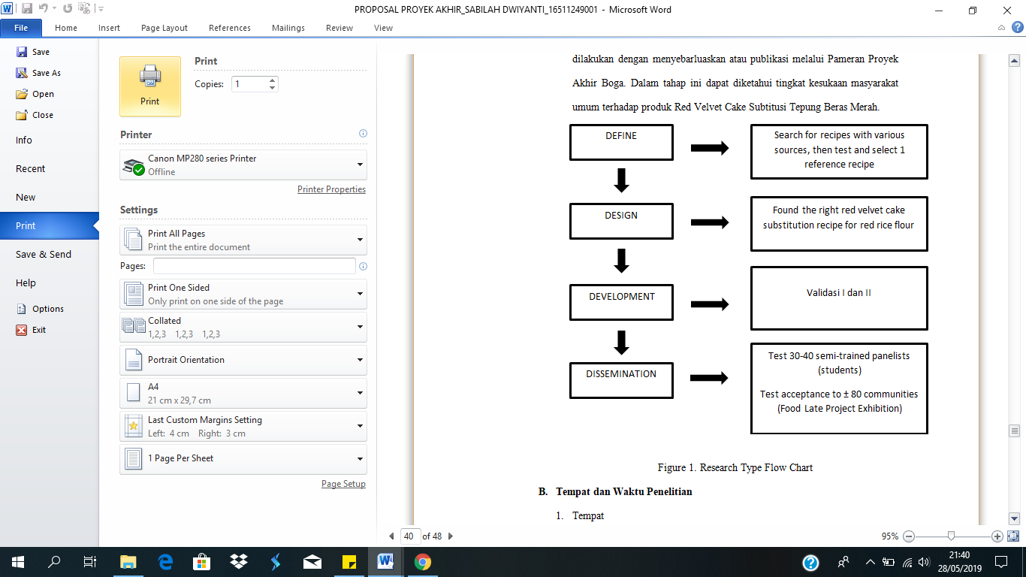

Pivcture.1 Figure Chart of Research Flow

The technique used to analyze data using descriptive research shows the level of explanation, namely asking for independent variables (not linked and compared). The following is the data source used. In this study, researchers used several panelists as data sources. Panelists assess the color, flavour, taste, texture and preference of Red Velvet Cake products. Data sources are presented in table 1.

Table 1. Data Sources
Research phase | Data Sources | Total
Test product phase 1 (validation 1) | Expert | 2 People
Test product phase 2 (validation 2) | Expert | 2 People
Test preference | Semi-trained panelists | At least 30 People
Disseminate: opening of the exhibition | Exhibition visitors | At least 60 People

The testing instrument in this study used 3 items, namely the first was a trial item in which the researcher selected 1 reference recipe from 3 recipes tested to the expert. Both form validation I and item validation II. The third is a trained panelist test form and community acceptance at the exhibition.

RESULTS AND DISCUSSION

RESULTS

Red velvet cake is one type of cake from France. Red velvet cake is velvety red and sweet and sour taste is a characteristic of the cake. In Canada, red velvet cake is known as a dessert from Eaton Restaurants & Bakery in the 1940’s and 1950’s. Besides the bright red color which is the main feature of this cake, it is located from the cream spread, namely cheese froasting made from cream cheese, added with a little refined sugar and vanilla. This product has advantages in cakes that have been substituted with brown rice flour with a percentage of 30% brown rice flour and 70% wheat flour. Adding butter and butter to the cake dough increases the smell so that the unpleasant smell of red rice flour can be disguised.

Define

Define stage is the initial stage which is done by searching for reference recipes. The reference recipe used is 3 (three) tested recipes. So that a reference product is obtained that truly meets the desired criteria. Then this reference recipe will be continued with product development by substitution using red bean flour in the next stage.

Table 2. Recipe for Red Velvet Cake Reference
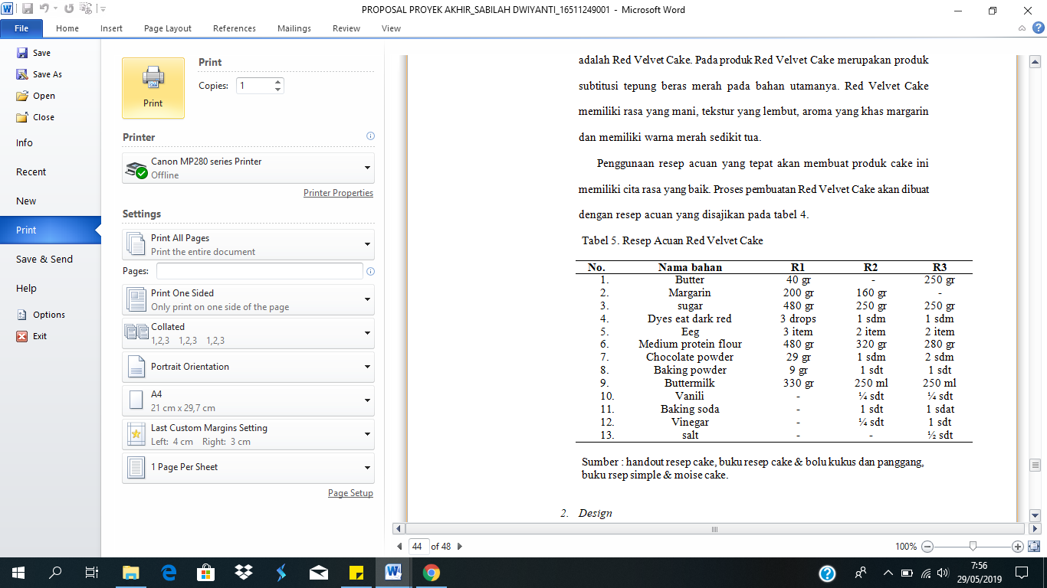

Table 3. Recipe for Selected Reference
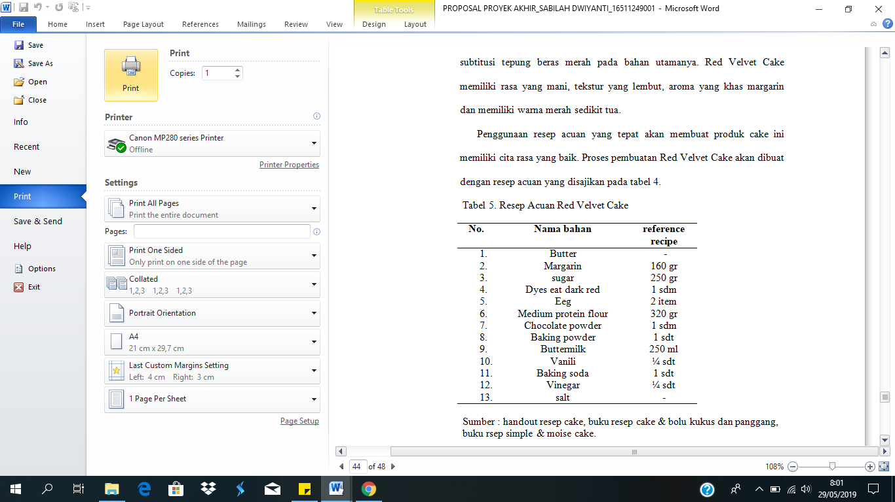

The selection of 1 reference recipe is because the results tested produce characteristics that are in accordance with the wishes of consumers.

Design

The first stage or define produces a reference recipe which is then continued in the design stage. This stage develops a reference recipe with the substitution of brown rice flour. The reference recipe will be substituted in a gradual manner with the lowest percentage then increased so that the percentage is received positively by the panelists. The appointed panelist is the supervisor with an assessment of the experimental forms that have been provided and then followed up by following up on the responses from the panelists.

Table 4. Recipe for Development of Red Velvet Cake
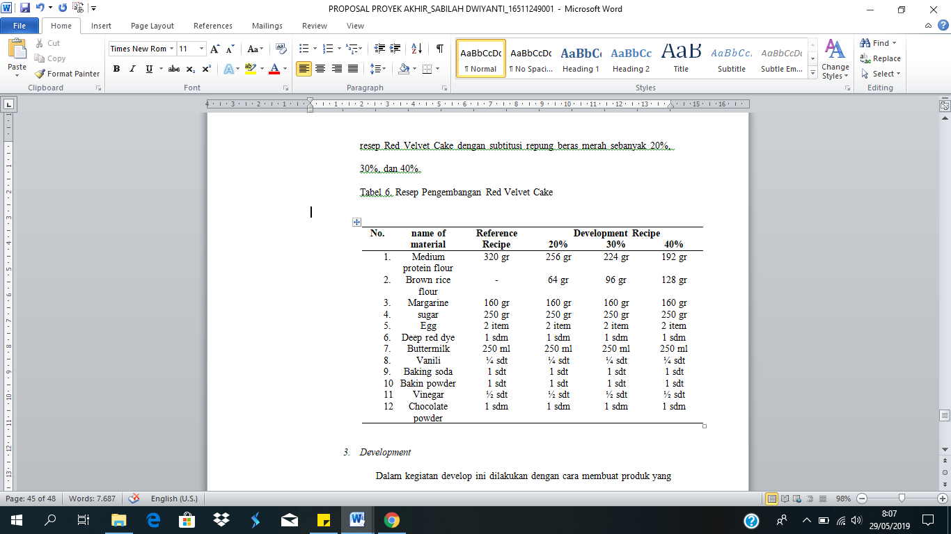

Based on the table above, determining the right recipe starts at the highest percentage, which is 40%, followed by a lower number.

Development

In this develop activity carried out by making a product that has been developed and then tested with a number of semi-trained panelists, namely students who have taken the subject of Food Quality Control and several experts or lecturers who are experts in the field of food criticism and suggestions that are useful to improve recipes and improvements before the final stage, namely dissemination. The results of this test carried out 2 stages of validation, namely Validation I and Validation II. The product testing process includes product manufacturing, product testing by 2 experts, processing analysis of test results data, and then making product repairs. This activity is carried out by experts in fields that are in accordance with the products developed.
Table 5. Recipe for Development of Red Velvet Cake
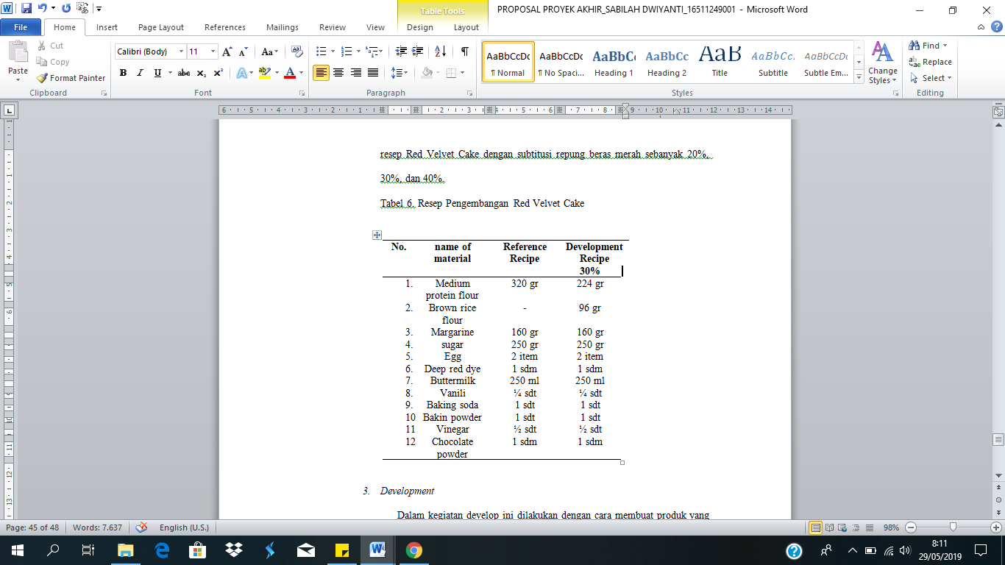

Next stage development is also carried out development testing or product trial activities carried out on the actual object targets. Development activities are carried out by making products that have been substituted and through validation II then tested with semi-trained researchers, namely 30 students who have taken the Food Quality Control course and experts or lecturers who are experts in the food sector. The following is a documentation of the panelist's test atmosphere that was conducted on Wednesday, March 27, 2019.
The summary of the results of semi-trained panelists testing 40 students can be seen in the following graph:

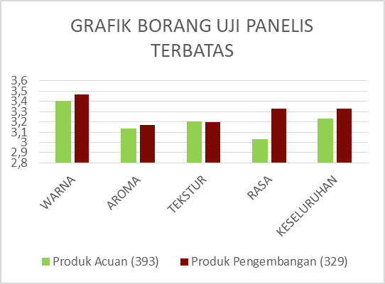
Figure 2. Graph of panelist test forms

Based on the results of the graph above, it can be seen that the level of acceptance of red velvet cake products with substitution of brown rice flour can be accepted by students where the color character reaches 3.47, aroma reaches 3.17, texture reaches 3.2, taste reaches 3.33 and overall reaches 3.33 compared to product reference. so it can be concluded that the red velvet cake products from red rice flour are well received by the panelists because they are more than 3 (tiha). The researcher can proceed to the next stage, namely the product exhibition by fixing a number of things according to the advice of semi-trained panelists written on the test form.
Next is the judging process carried out by 3 judges by assessing characteristics such as aroma, taste, texture, and color. Judging is done to get the value of the product that has been tried by the assessors. The assessment is held on Saturday, March 23, 2019 in Room 209 A and 209 B.

Disseminate

Dissemination is the last stage of this research model. This stage is often referred to as the dissemination stage or publication with the community acceptance test. This test was carried out simultaneously with the entire 2016 batch of Food and Cooking Engineering Education which was held on Thursday, April 25, 2019 at the UNY Auditorium. Just like in the development stage, at this stage also measuring the achievement of objectives. Testing is done by distributing forms to visitors who have tried the product.
Other dissemination is by making booklets to be disseminated to the community. So that people can more easily get the recipes that have been studied.

DISCUSSION

After testing the product preferences, the next stage is the exhibition. Products that have been tested and have produced book recipes are then exhibited to get an assessment from the general public. The exhibition is also a means of publication to introduce new products to the public about the use of brown rice flour.
In the exhibition red velvet cake products are presented and packaged as well as possible to attract visitors' interest and attention. With product exhibitions held, it can be seen the level of preference for product development. Exhibitors provide 80 product samples to be tasted by visitors. This is done to get responses from the general public about the new products produced. The results of the final product acceptance test are presented in the following Table:

Table 6. Table of Exhibition Form Results
Characteristics | average | Results
colour | 3.675 | Very liked
Flavour | 3.475 | liked
Tekstur | 3.5 | liked
Taste | 3.475 | liked
whole | 3.65 | Very liked

Based on the calculations above, it can be seen that the level of acceptance of the red velvet cake product with the substitution of red rice flour has a color character of 3,675, aroma reaches 3,475, texture reaches 3.5, taste reaches 3,475 and overall 3.65. From the data can be described on the graph :

Figure 3. Graph of Exhibition Form Results

According to the above data it can be seen that the level of acceptance of the red velvet cake product substitutes for red rice flour. Data on acceptance level variables were obtained through the average score of color, taste, texture and aroma acceptance with 80 panelists. The average results show color characters reaching 3,675, scents reaching 3,475, texture reaching 3.5, taste reaching 3,475 and overall 3.65 most of the panelists like the product of red velvet cake substitution of brown rice flour. Thus it can be concluded that red velvet cake substitution of brown rice flour can be accepted by the community. The results of the final project exhibition on April 25, 2019 are nicely.

After that, the last stage of this research was to test the nutritional value information. In this study the main purpose is to obtain an information related to the nutritional content of a product and usually listed on the label on the packaging of a product. Testing the nutrient content of a product is important in order to find out how big the percentage of a nutrient is. Testing the nutritional content using proximate analysis testing. Proximate analysis is a method of chemical analysis to identify nutrient content such as the amount of protein, carbohydrate, fat, ash and water. The results of testing the nutritional value of red velvet cake substituted for red rice flour are presented in the following table.

Table 7. Nutritional Value Information Test Results
No. | Sample codes | Analisis | Results
 | Red Velvet Cake Substitution | water | 52.914%
 | Brown Rice Flour | Ash | 2.2937%
 |  | Protein | 7.7889%
 |  | Oil | 19.8619%
 |  | Coarse fiber | 7.7570%
 |  | Carbohydrate | 9.3841%
 |  | Energy | 249.1383 kal/100g

Based on the nutritional value information above, it can be seen that the results of the water reached 52,914%, Ash(Dust) 2.2937%, Protein 7.7889%, Fat 19.8619%, Rough Fiber 7.7570%, Carbohydrates 9.3841% and Energy 249.1383 kal / 100g. Thus it can be concluded that red velvet cake substitution of red rice flour can be accepted by the community with good nutritional results so that it is no doubt to be consumed by the wider community.

CONCLUSION

Based on the results of observations, analyzes and data obtained from the results of research on the manufacture of red velvet cake products with the substitution of red rice flour, it can be concluded that:
- The result of the red velvet cake recipe with the substitution of red rice flour is 30% red rice flour: 70% flour.
- Analysis of nutritional value information and community acceptance from the results of the acceptance test for red velvet cake products with the substitution of red rice flour which includes color, flavour, texture and taste is good or acceptable.

REFERENCES

Anni Faridah. 2008. Patiseri Jilid 1 Untuk SMk: Jakarta: Directorat Pembinaan Sekolah Menengah Kejujuran.

Endang Mulyatiningsih, 2011. Metode Penelitian Terapan Bidang Pendidikan. Yogyakarta: UNY Press

Gisslen, W. 2005. Professional Baking, fouth edition. Canada: John Wiley & Sons, Inc.

Hamidah, Siti. (1996). Patiseri. Yogyakarta: FPTK IKIP Tata Boga http/www.yahoo.com. 12 Desember 2010, pukul 18.00 WIB

Sugiyono. 2010. Metode Penelitian Kuantitatif Kualitatif & RND. Bandung: Alfabeta.

Sumartini, dkk. 2018. “Kajian Peningkatan Kualitas Beras Merah (Oryza nivara) Instan Dengan Cara Fisik.” Pasundan Food Technology Journal, 5(1)

Tuty Anggraini, dkk. 2017. “Karakteristik Sponge Cake Berbahan Dasar Tepung Beras Merah, Hitam dan Putih Dari Beberapa Daerah di Sumatra Barat.” Jurnal Litbang Industri, 7(2).

Yuwanta, T. 2010. Telur dan kualitas telur. Gadjah Mada University Press, Yogyakart

